**Lab : 06**

**Resistor in Parallel, Current Divider (current in parallel)**

**Verification of Kirchhoff’s Current law**

# **PURRPOSE:**

* To know about resistor, voltage and current in parallel
* Verification of Kirchhoff’s Current Law

**EQUIPMENT:**

* Breadboard
* Resistors: R1, R2, R3, R4
* Connecting leads (Jumper wires)
* DMM
* Voltage

**RESISTORS IN PARALLEL**

When two or more resistors are individually connected between two separate points (nodes) in a circuit, they are in parallel with each other. A parallel circuit provides more than one path for current.

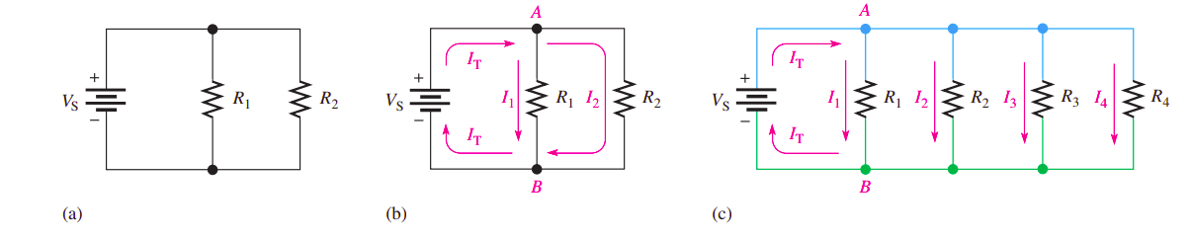

**If there is more than one current path (branch) between two separate points and if the voltage between those two points also appears across each of the branches, then there is a parallel circuit between those two points.**

**VOLTAGE IN A PARALLEL CIRCUIT**

The voltage across any given branch of a parallel circuit is equal to the voltage across each of the other branches in parallel. As you know, each current path in a parallel circuit is called a branch.

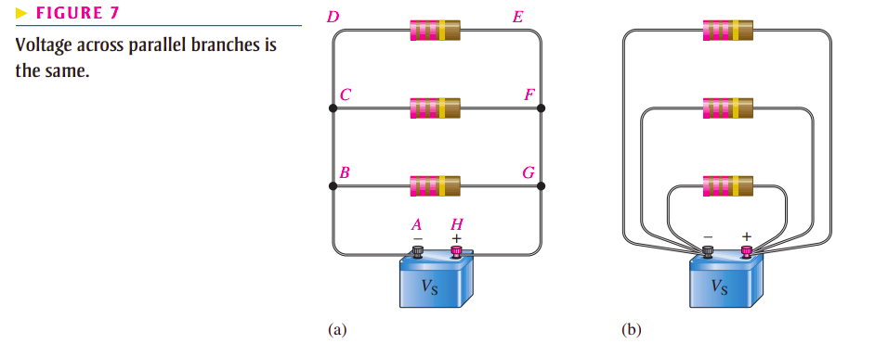

**TOTAL PARALLEL RESISTANCE**

When resistors are connected in parallel, the total resistance of the circuit decreases. The total resistance of a parallel circuit is always less than the value of the smallest resistor.

**KIRCHHOFF’S CURRENT LAW**

Kirchhoff’s current law, often abbreviated KCL, can be stated as follows:

**The sum of the currents into a node (total current in) is equal to the sum of the currents out of that node (total current out)**

**I (total) = I1 + I2 + I3**

**The algebraic sum of all of the currents entering and leaving a node is equal to zero.**

$$\sum_{i=1}^{n}{I=0}$$

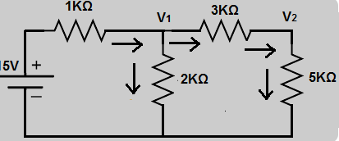

**Procedure**

1. Construct the circuit on breadboard.
2. Using a source voltage of 10 V, calculate the current flowing through source (I total). using Ohm' Law i.e $I_{t}$ = $v_{t}/R_{t}$,
3. Compute current $I_{2}$, using current division rule and branch current is at node-1 and 2 employing Kirchhoff's Current Law
4. Record the computed value of currents in applicable column of Table-2.
5. Observe that node equation $I_{t}= I_{2}+I_{3}$ is valid at both node-fas well as node-2.
6. Turn the power supply on and rotate power supply knob until the display indicates 9V
7. Using DMM, measure all currents at node-1 and node-2.
8. Record your measurements in Table2, using the current names assigned in Figure-2
9. Note that ammeter must be connected in series with branch under test where current is required to be measured.
10. Compare the measured result with the calculated values and determine percentage error.
11. Percentage Error (%) = [((Measured Value-Computed Value)/Computed Value) x100).
12. Doe the experimental measurements verify the Kirchhoff's Current Law statement at nodes-1 and 2 within an error margin of±10%.

**LAB TASK 1**

|  |  |  |  |
| --- | --- | --- | --- |
| **Current at 9v Supply voltage** | **Calculated Value (mA)** | **Measured Value (mA)** | **% ERROR** |
| **Total Current $I_{t}$** |  |  |  |
| **Current in branch 1** |  |  |  |
| **Current in branch 2** |  |  |  |

**LAB TASK 2**

* Find out the voltage across each resistor (R1, R2, R3, R4) and mention it on the table.
* Find out the sum of voltage across the circuit.

**LAB TASK 3**

* Find out the resistance of each resistor (R1, R2, R3, R4) and also mention it on the table.
* Find out the sum of resistance across the circuit and also mention it on the table.